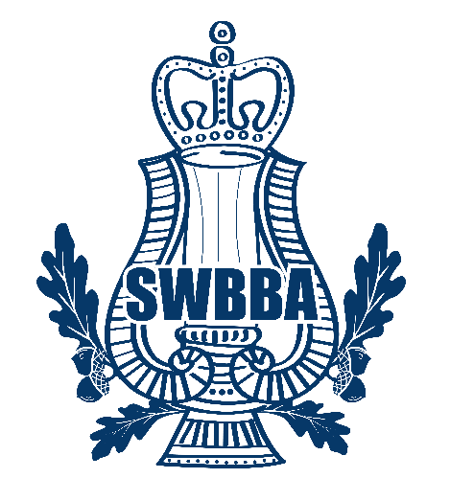

**SOUTH WEST BRASS BAND ASSOCIATION**

**1st “ENTERTAINING BRASS” 2025**

**ENTRY FORM**

**The ............................................................................................. Band herewith apply to enter the “Entertaining Brass” festival being held at the Upton Vale Church Torquay on**

**Saturday 12 July 2025, and agree to abide by the Rules as set out in the schedule.**

(Please write clearly and in block letters)

Name of Secretary: .................................................................................................

Address: .................................................................................................

.................................................................................................

.................................................................................................

Post Code: .................................... Telephone: ..........................................

**Email address (important)** ……... ………………………………...........................

Please confirm your band and all players consent to any images created by SWBBA may be used on the Association website/social media and press releases

Sign: ..............................................................................

Signed: .................................................................................(Secretary)

Conductor at Festival ..................................................................................................

(for inclusion in Programme)

**ENTRY FEE - £50.00 (non-SWBBA member bands £75.00). NON REFUNDABLE**

**Please return this form, by no later than 19th April 2025, to the Festival Controller**

**Robin Teague, An Lety Coth, De Lank, St Breward, Bodmin, Cornwall, PL30 4ND**

[**teaguerobin@aol.com**](mailto:teaguerobin@aol.com) **/ 07788414655**

**Confirmation of BACS Payment for £50.00 / £75.00 to:-**

**South West Brass Band Association**

**Account Number: - 63683710**

**Sort Code: - 20-04-59**

**Barclays Bank**